Conduit guide

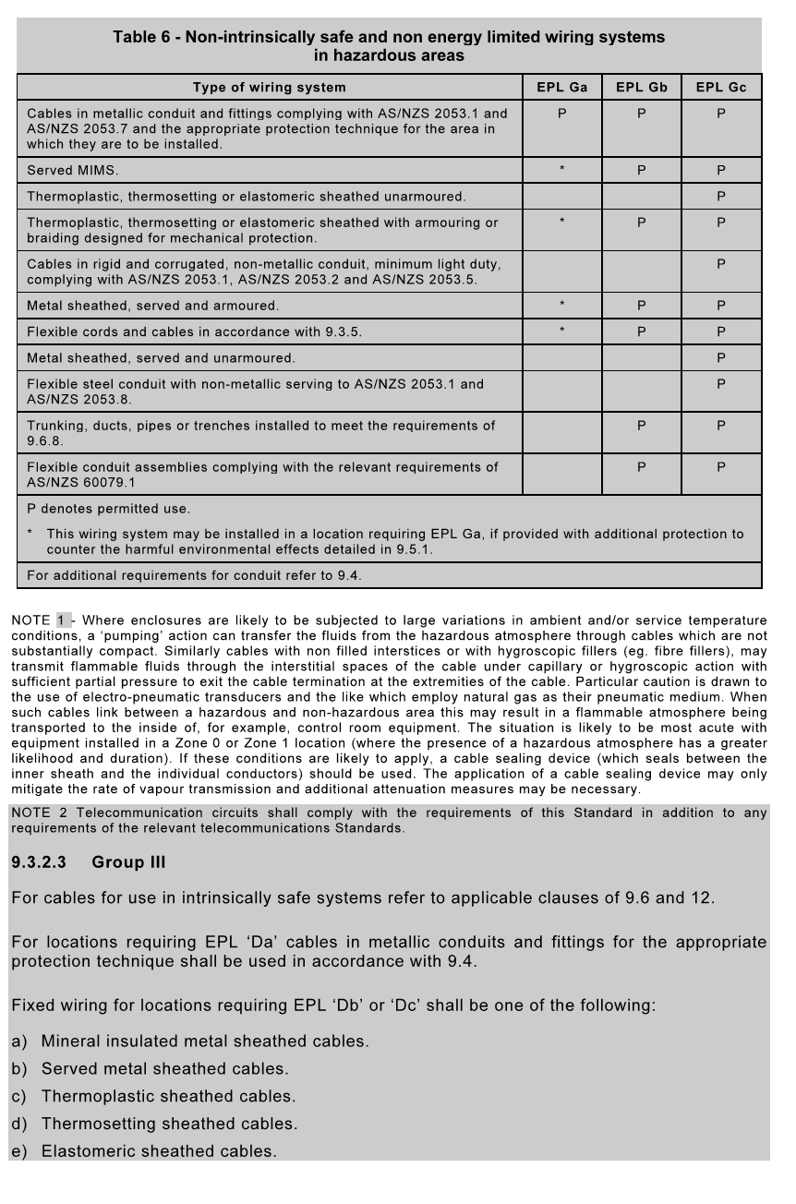

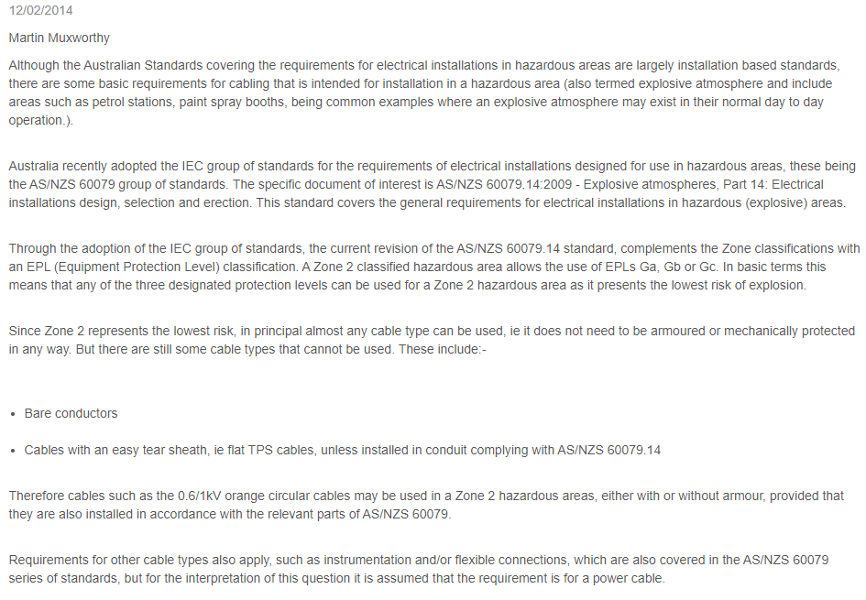

<https://www.voltimum.com.au/content/cables-zone-2-group-iib-hazardous-area>